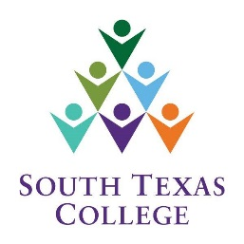

192575
Computer Science CITP Faculty Preparation Day
[Tuesday, August 17 2021]
Microsoft Teams
9:30 a.m. – 11:30 a.m.

AGENDA

- 09:30AM - Dr. Kevin Peek – “Current State of Affairs Regarding CBE Education”

- 10:00AM - Dr. Andres Padilla-Oviedo – Transitioning to Blackboard Ultra

- 10:30AM - Saul Garza – Center of Learning Excellence Coordinator

- 11:00AM - Saeed Molki
  - Department Updates
  - Incompletes
  - Section outlines and Concourse
  - StarFish
  - Division Curriculum Committee Nominations (two individuals)
  - Acknowledging FLAC and Concourse

- Don’t forget Remote Check-in: COSC2021

- Questions/Concerns?

